<https://www.facebook.com/HarwoodHCA/>

<https://scontent-atl3-1.xx.fbcdn.net/v/t1.0-9/13938614_1305250219503198_8962705029379281342_n.jpg?oh=a0ffe562642dcd02265c305e39e86f15&oe=583EB36A>

A Harwood neighborhood celebration: National Night Out

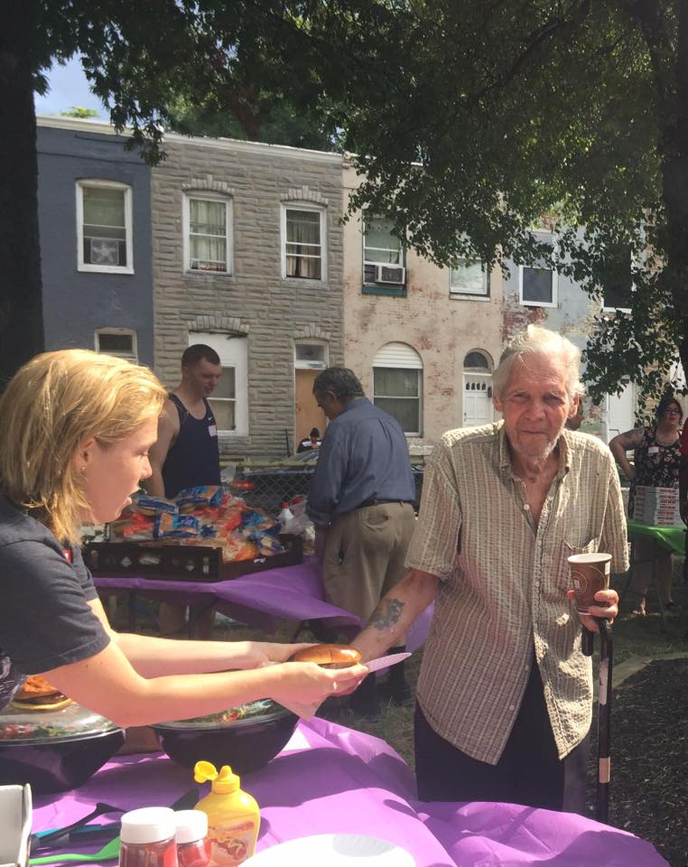

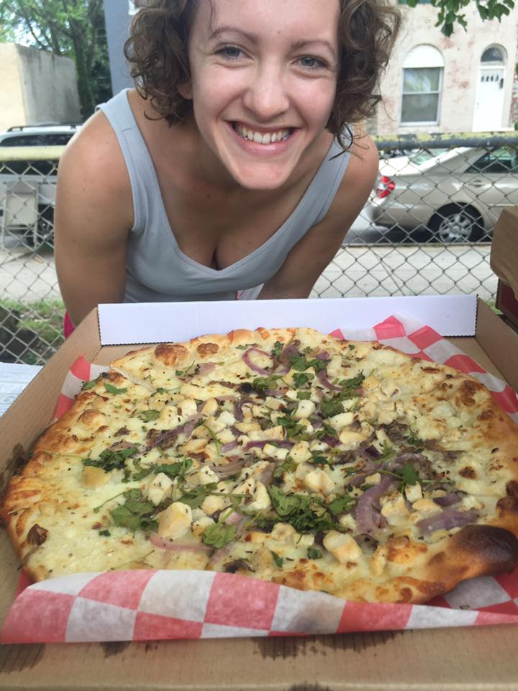 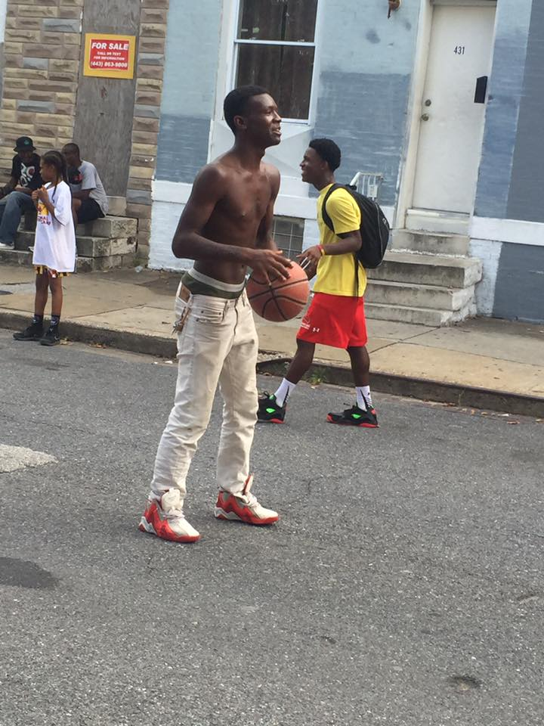

Jumpers at the Community Center

